**Ideation Phase**

**Define the Problem Statements**

|  |  |
| --- | --- |
| Date | 29 September 2022 |
| Team ID | PNT2022TMID33342 |
| Project Name | Project – Personal Expense Tracker |
| Maximum Marks | 2 Marks |

**Customer Problem Statement Template:**

The personal finance entails all the financial decisions and activities that a Finance app makes your life easier by helping you to manage your finances efficiently. A personal finance app will not only help you with budgeting and accounting but also give you helpful insights about money management. Personal finance applications will ask users to add their expenses and based on their expenses wallet balance will be updated which will be visible to the user. Also, users can get an analysis of their expenditure in graphical forms. They have an option to set a limit for the amount to be used for that particular month if the limit is exceeded the user will be notified with an email alert.

|  |  |
| --- | --- |
| **I am** | User, need to reduce unwanted expenses and save money. |
| **I’m trying to** | Needs to monitor and control expenses in day-to-day life. |
| **But,** | It takes long time to load and I couldn’t get time to analyse every expense I made. And reading or viewing each expenses every time was not confortable for me in eachtime. |
| **Because** | I am not comfortable with listing each day expenses and can’t find an appropriate way to handle it. |
| **Which makes me feel** | I consider listing a expense manually are frustrated to use the application. |

**Reference:**

<https://miro.com/app/board/uXjVPSKo34o=/?share_link_id=576579390094>

**Example:**

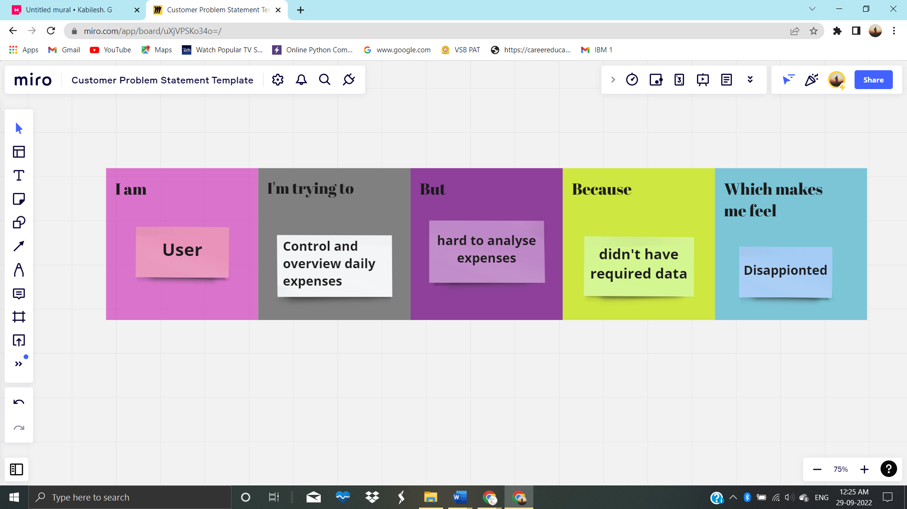

|  |  |  |  |  |  |
| --- | --- | --- | --- | --- | --- |
| **Problem Statement (PS)** | **I am** | **I’m trying to** | **But** | **Because** | **Which makes me feel** |
| PS-1 | User | Control daily expenses | Hard to analyse expenses | Didn’t have necessary data | Disappointed |
| PS-2 | User | Overview expenses | All expenses are not reviewed. | Lack of necessary data | Annoying |